25MW发电项目
技术方案
25MW Power Plant Project

(重油HFO电站)

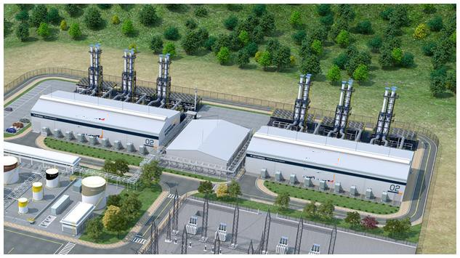

20230222

1.概述overview
  - 根据客户需求:建立重油电厂,考虑到高溫环境影响，布置电厂容量25MW.11KV 50HZ.
拟建立额定功率25W重油电厂, 110%最大负载为27.5MW.
布罝6台MAN18v2832 4MW重油发电机组,一台调峰3.5MW重油发电机组.
电站总容量6台*4MW+1台*3.5MW=24+3.5=27.5MW.
考虑到机组轮流保养需要以及维持电站85--90%的运行效率.
保证电厂长期稳定供电23.37--24.75MW.
电厂设施:油库,水池,变电站,钢结构厂房,
7台套发电机组布置图见附件《发电厂区总体平面布置图》.
燃料为重油和柴油。
配套控制/安全报警系统,润滑油/冷却水/压缩空气/排气系统,高低压电系统等。
1.1. According to customer requirements: Establish a heavy oil power plant in South Africa, and arrange the plant capacity of 25MW.11KV and 50HZ considering the impact of high temperature environment. It is proposed to build a heavy oil power plant with rated power of 25W and 110% maximum load of 27.5MW. There are six MAN18v2832 4MW heavy oil generator sets and one 3.5MW heavy oil generator set for peak regulating. Total power station capacity: 6 *4MW+1 *3.5MW=24+3.5=27.5MW. Taking into account unit rotation maintenance needs and maintaining 85-90% operating efficiency of the plant. Ensure long-term stable power supply of 23.37-24.75MW. Power plant facilities: oil depot, water pool, substation, steel structure workshop, For the layout of the 7 generator sets, please refer to the attached General Layout of the Power Plant. The fuel is heavy oil and diesel. Supporting control/safety alarm system, lubricating oil/cooling water/compressed air/exhaust system, high and low voltage electric system, etc.

1.3发电机组项目的主要技术参数如下：
Main technical parameters of generator set are as follows:
◆ 总发电输出功率：27.5MW
Total output power of generation: 27.5MW
◆ 发电机组型号: 6台MAN18V2832 4MW发电机组,1台BB3345 3.5MW发电机组.
Model of the generator set: 6sets MAN 18V2832 4MW generator set,one sets BB3345 3.5MW gensets.
◆ 发电机组数量：7套
Number of generator sets: 7sets
◆机组输出电压：11KV
Output voltage of the unit: 11KV
◆频率： 50Hz
Frequency: 50Hz
◆燃料：柴油和重油
Fuel: DO /HFO
◆冷却方式： 压力水循环水冷形式。
Cooling method: Pressure water circulating water cooling by airing.

2. 技术方案

Technical Proposal
2.1 电站总体布置
General layout of power station
厂区内按功能划分:
主发电厂房(含发电机组,电气设备,监控室).
辅助室:燃油处理/供水房,辅助变压器区11/0.4kv.
原留设备:主变压器区,油库,水池,道路,绿化带.
The factory is divided according to functions:
Main power plant (including generator set, electrical equipment, monitoring room).
Auxiliary room: fuel oil treatment/water supply room, auxiliary transformer area 11/0.4KV.
Original equipment: main transformer area, oil depot, pool, road, green belt.

辅助变压器布置在厂区端头，为本厂区内的主发电厂房提供动力及照明电力供应。
主机房内,发电机组和辅助系统设备按模块化设计并分区布置，发电机组与辅助系统设备区之间以纵向贯通走道自然分隔，二者之间的连接管路采取空中高架或地沟敷设形式；相邻的两台主机组之间留出足够空间间隔形成横向通道。
纵横交错连通的走道可以使人员和零配件到达厂房内任何位置，为机组及辅助设备的日常巡视、设备检修等工作提供便利。
机房厂房内上方安装1台承重20吨以上的梁式移动吊钩，用于重量较大零部件的维修吊装。由于机组高度较高，机组两侧及发电机侧架设扶梯平台供工作人员登高操作。
Auxiliary transformers are arranged at the end of the plant to provide power and lighting power supply for the main power plant in the plant area.
In the main machine room, the generator set and auxiliary system equipment are arranged according to the modular design and partition. The natural separation between the generator set and auxiliary system equipment area is through the longitudinal walkway. The connecting pipes between the two are in the form of aerial overhead or trench laying. Leave enough space between two adjacent host groups to form a transverse channel.
The crisscross connected walkway can make personnel and spare parts to reach any position in the plant, for the unit and auxiliary equipment daily patrol, equipment maintenance and other work to provide convenience.
one beam-type mobile hooks with a bearing capacity of more than 20 tons are installed above the machine room and workshop for maintenance and hoisting of heavy parts. Due to the high height of the unit, escalator platforms are set up on both sides of the unit and the generator side for staff to climb up and operate.

电气控制房顶部分别安装进气鼓风机、排气换气风扇，为机房及设备冷却通风和发动机燃烧提供足够的新鲜空气。厂房上方设置消防报警探头等，厂房内配备固定及移动式消防灭火装置。主厂房顶面布置排气烟囱及排气消音器等设备,并预留余热锅炉安装位置。发电机组采用冷却塔冷却。
The electrical control roof is equipped with intake blower and exhaust ventilation fan to provide sufficient fresh air for cooling ventilation and engine combustion of the machine room and equipment. The workshop is equipped with fire alarm probes and fixed and mobile fire extinguishing devices. Exhaust chimney, exhaust muffler and other equipment are arranged on the top of the main workshop, and the installation position of waste heat boiler is reserved. The generator set is cooled by cooling tower.
电气设备及监控室分隔为高压柜室、低压柜室、主控操作室三部分。各机组的高低压电气柜布置在电气设备柜房内.
进,出线柜分别与机组主发电机及厂房外的变电/配电设施相连，实现发电的上网输出。主控操作间内设置一个集中操控台，对每个单元组的发电机组进行实时集中监视控制操作。
Electrical equipment and monitoring room are divided into three parts: high voltage cabinet room, low voltage cabinet room and main control operating room. The high and low voltage electrical cabinets of each unit are arranged in the electrical equipment cabinet room.
The inlet and outlet cabinets are respectively connected with the main generator of the unit and the substation/distribution facilities outside the plant to realize the online output of power generation. A centralized control console is set in the main control room to monitor and control the generator sets of each unit group in real time
电站储罐布置在安全的区域，将此类危险易燃易爆品集中布置在该区,并与其他区域进行隔离，便于进行管理控制，提高运行安全性。
The storage tank of the power station is arranged in a safe area, and such dangerous inflammable and explosive materials are centrally arranged in this area and isolated from other areas to facilitate management and control and improve operation safety.

2.2.设计环境
机组的环境参数：
外部环境温度--------------------------------0~55℃ (室內0~40℃ )
淡水温度-----------------------------------------30℃
相对湿度-----------------------------------------60 %
大气压强---------------------------------------101.3kPa(760 毫米汞柱)
增压器的背压---------------------------------350毫米水柱(最大400毫米水柱)
热交换的设计基于30℃的淡水温度。
Design condition
The engine will be operated on Natural gas.
Capacity of the genset can be decided under the following design conditions:
Ambient temperature--------------------------------------------0~55℃ (Indoor 0 ~ 40 ℃)
Fresh water temperature------------------------------------------30℃
Relative humidity----------------------------------------------------60%
Atmospheric pressure------------------------------------------101.3kPa(760mmHg)
Back pressure of turbo-charger---------------------------350mmAq(max 400mmAq)
Heat exchangers will be designed at fresh water temperature 30℃.

2.3.发电机组标准
Technical standards of Generator Set
机组采用标准：
Applicable standards for the unit:
- . GB：中国工业标准
- GB: china Industrial Standard
3). ISO：国际标准化组织标准(机组性能适用ISO3046-1标准)
ISO: Standards of International Standard Organization (ISO3046-1 is applicable to the performance of the unit)
4). IEC：国际电工技术委员会标准(性能)
IEC: Standards of International Electrotechnical Commission (performance

2.4. 主要技术规格参数
Main technical specifications and parameters

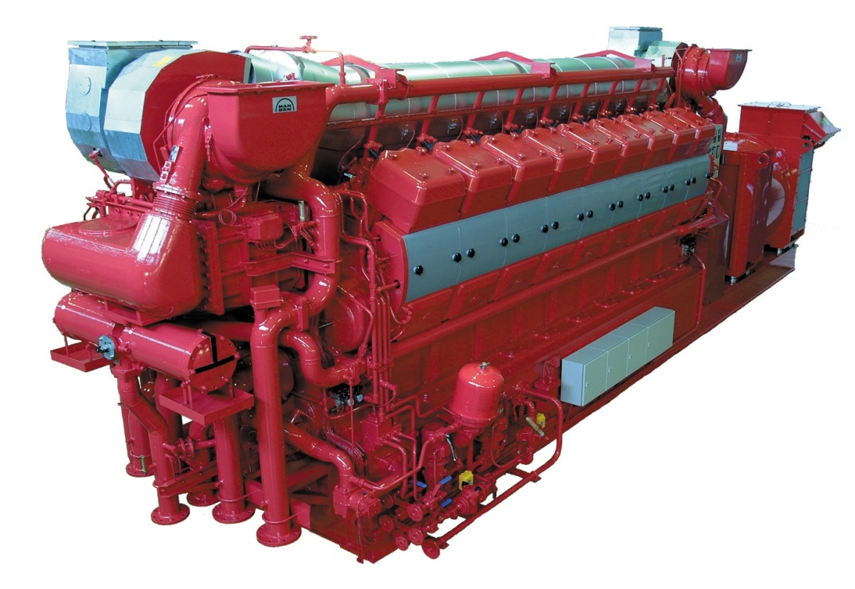

表1发电机组主要技术参数汇总表(标准条件下)
Table 11 Summary sheet of main technical parameters for generator set
(under standard conditions)
机组型号  Set model |  | 4000GF
发电机组额定功率  Rated power of generator set | kW | 4000
功率因数  Power factor |  | 0.8
转速  Rotating speed | rpm | 750
排烟温度  Exhaust gas temperature | ⁰C | 420
允许的排气背压  Allowable exhaust back pressure | kPa | 4.5
燃料消耗率  Fuel consumption | g/kwh | 190+5%
润滑油消耗率  Lubricating oil consumption | g/kWh | 0.4-0.45
缸径/冲程  Cylinder diameter/stroke | mm/mm | 280/320
缸套水回水/出水温度  backwater/effluent temperature of cylinder liner water | ⁰C/⁰C | 74/82.5
缸套水量  Water volume of cylinder liner | m³/h | 82
输出电压  Output voltage | kV | 11
频率  Frequency | Hz | 50
发电机组净重  Net weight of gensets unit | T | 71
发电机组外型尺寸  External dimension of gensets unit | m | 10707×3635×2449（mm）(长x宽x高)(length x width x height)

表2 发动机技术参数表(标准条件下)
Table 2 Technical parameters of engine (under standard conditions)

项 目  Item | 单 位  Unit | 数 值  Value
发动机型号  Model of engine |  | MAN 18V2832
发动机额定功率  Rated power of engine | kW | 4230
燃气-热耗和燃油耗gas heat rate and fuel consumption | g/kwhr | 188+5%
气缸数量  Number of cylinder | 个  Pcs. | 18
缸径  Cylinder diameter | mm | 280
冲程  Stroke | mm | 320
排量  Discharge capacity | L | 300
转速  Rotating speed | rpm | 750
活塞平均速度  Mean velocity of piston | m/s | 10
润滑油填充容量  Filling capacity of lubricating oil | m³(kg) | 2.0(1600)
水填充容量  Water filling capacity | m³(kg) | 1.2(1200)
长Length ×宽Width×高Height | mm | 6628* 1815 *3449
净重  Net weight | kg | 45000

表3 发动机噪音指标(标准条件下)
Table 9 Noise index of engine (under standard conditions)
噪音频谱  Frequency spectrum of noise | Hz | 32 | 63 | 125 | 250 | 500 | 1000 | 2000 | 4000 | 8000
发动机功率  Engine power | kW | 4230
进气噪音 (空气)  Inflow noise (air) | dB |  | 109 | 105 | 104 | 101 | 108 | 112 | 126 | 113
排气噪音  Exhaustion noise | dB | 97 | 112 | 115 | 119 | 113 | 119 | 120 | 119 | 110
机组噪音  Set noise | dB | 51 | 72 | 86 | 93 | 95 | 100 | 101 | 102 | 88

表4发电机技术数据表(标准条件下)
Table 10 Technical data sheet of electric generator (under standard conditions)
型号ABB/TFC  Model |  | TFC
额定功率  Rated power | kW | 4230
功率因数  Power factor | COSφ | 0.8
频率  Frequency | Hz | 50
电压  Voltage | kV | 11
转速  Rotating speed | rpm | 75 0
允许超转速  Allowed overspeed | rpm | 120%
效率  Efficiency | % | 96
惯性矩(飞轮)  Moment of inertia (flywheel) | kgm² | 590
重量  Weight | kg | 16500
抗无线电干扰等级  Anti-radio jamming grade |  | N
结构形式  Structure type |  | IBM3
绝缘等级  Insulation class |  | F/B
防护等级  Protection class |  | IP23
在额定功率下允许温升  Allowable temperature rise under rater power | ⁰C | 80
最高周围环境温度  Maximum surrounding ambient temperature | ⁰C | 40
总谐波失真  Total harmonic distortion | % | 3%
电抗及时间常数
Reactance and time constant
xd直轴同步电抗  xd direct-axis synchronous reactance | % | 195.6%
xd¹直轴瞬态电抗  xd¹ direct-axis transient reactance | % | 24.4%
xd”直轴次瞬态电抗  xd” direct-axis subtransient reactance | % | 16%
Td”次瞬态电抗时间常数  Time constant of Td” subtransient reactance | sec | 0.018
Td 时间常数  Td time constant | sec | 4.187

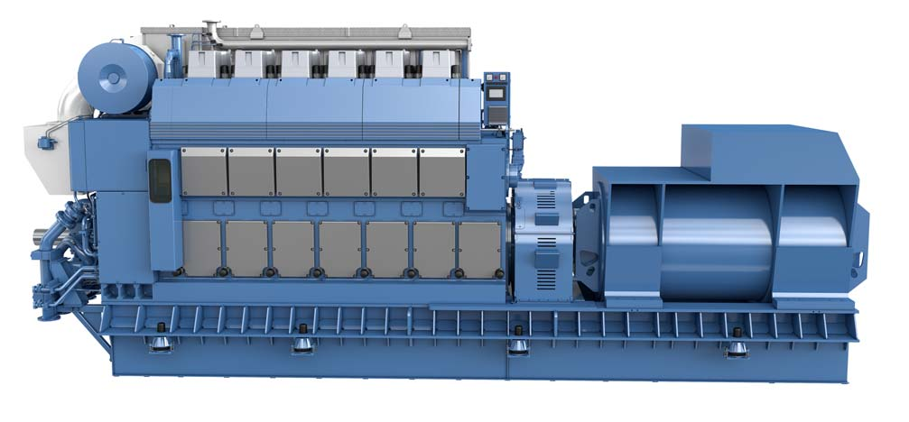

BB3345 3.5MW 发电机组技术参数
Project 项目 | unit单位 | technical parameter 技术参数
model型号 |  | 3500GF
Cylinder arrangement  气缸排列形式 |  | L直列
Rated power  额定功率 | kW | 3500
Rated speed  额定转速 | rpm | 750
rated voltage  额定电压 | kV | 10
Rated current  额定电流 | A | 252.6
frequency  频率 | Hz | 50Hz
power factor  功率因数 |  | 0.8 (lagging)
phase  相数 |  | 3-phase
Voltage volatility  电压波动率 | % | ±1
Frequency volatility  频率波动率 | % | ±0.5
Steady state voltage regulation  稳态电压调整率 | % | ±2.5
Steady-state frequency regulation  稳态频率调整率 | % | 5
Transient voltage regulation  瞬态电压调整率 | % | ±20～-15
Stable time  稳定时间 | s | 5
Voltage regulation mode  电压调整方式 |  | Auto AVR
Speed regulating mode of unit  机组调速方式 |  | Electronic speed 电子调速
Frequency regulation mode  频率调整模式 |  | Automatic or manual自动或手动
Unit lubrication mode  机组润滑方式 |  | Pressure, forced lubrication压力,强制润滑
Lubricating oil type  滑油类型 |  | SAE 4030
Start the way  启动方式 |  | compressed air 压缩空气
Fuel oil type  燃料油类型 |  | HFO重油/柴油DO
Engine cooling mode  发动机冷却方式 |  | high and low temperature two, low temperature water close type cooling高低温两路，低温水由闭式冷却器
Generator cooling  发电机冷却方式 |  | water cooling  水冷
Insulation grade绝缘等级： |  | （F）
Protection grade防护等级： |  | IP23
Unit fuel consumption  机组燃油消耗率 | g/kWh | 194g/kWh+5%
Lub-Oil consumption滑油消耗率 | g/kWh | 0.6-0.8
Coupling type联接方式 |  | elastic coupling弹性联轴器
Paint color according油漆颜色 |  | to owner's requirement根据业主要求
Installation method安装方式 |  | common base elastic shock absorption installation  共同底座弹性减震安装
Overall dimensions 外形尺寸 | mm | 9800×2500×4000
net weight of the unit机组净重 | KG | 65000

3. 发电机组及系统
Turbine Generator Set and System

3.1. 系统组成
System composition
发电机组主要由发电主机组,机组辅助系统,并网发电系统,燃油系统组成。
generator set is mainly composed of generator set and auxiliary system, grid-connected power generation system, fuel system.

3.1.1. 发电机组及辅助系统
Generator set and auxiliary system
发电主机组由发动机、主发电机、公共底架及附属设施(如电动盘车、油雾探测器等)组成。
机组一侧安装的机旁柜、仪表柜可以对发动机的工作状态、报警指示等进行显示、监测，发出指令对发动机进行实时控制。机组的启动准备、启动、同步并网、负荷控制、停机及紧急停机等操作均可在机组机旁柜上进行。
The maingenerator set is composed engine, main generator and common underframe and ancillary facilities (electric barring device, oil mist detector, etc.)
The side cabinet and instrument cabinet installed at the side of the set are able to display and monitor the working condition and alarm instruction of the engine as well as give orders to engine for real-time control. The startup preparation, start, synchronized grid connection, load control, shutdown and emergency shutdown of the set may carry out on the side cabinet of the set.
发动机为四冲程、L型布置、废气涡轮增压、空气中间冷却、燃油直喷发动机。
engine is the engine with four strokes, L-type arrangement, exhaust turbine pressurization, intercooling.
发动机用压缩空气进行启动，高压空气在主启动阀控制下依次按序进入各气缸中推动活塞运动，实现发动机启动。
Compressed air is used for the startup of the engine, and the high pressure air enters into the cylinders successively in sequence under the control of the main starting valve to drive the piston motion and achieve the startup of the engine. By using such startup mode, sparkles possibly generated in the DC motor startup can be avoided, which is safer under the service environment of the gas.
该发动机压力冷却水循环系统分为一次水循环(发动机内循环)和二次水循环(机组外循环)，循环系统的冷却水泵为电机驱动式齿轮泵，冷却介质不采用防冻液，水质要求参见所附资料。一次循环水在发动机内部进行封闭循环，由主要冷却发动机气缸套、增压器等高温部件。空气中冷器分为高温段和低温段两部分，其高温段由一次循环水进行冷却。从冷却塔来的二次循环水先后流经空气中冷器低温段、润滑油冷却器、一次循环水冷却器，分别对增压后的空气、润滑油、二次循环水进行冷却散热。机组循环系统中设有若干温控阀，保证水温控制在设计范围内。
The pressure cooling water circulation system of the engine is divided into the primary water circulation (internal circulation of the engine) and secondary water circulation (circulation outside the unit). The cooling water pump of the circulation system is the motor driven gear pump, and the antifreezing fluid will not be used for the cooling medium. See the water quality requirements in the attached material. Primary circulating water is in closed circulation in the engine interior, mainly for the cooling of high-temperature components, such as cylinder liner of the engine, pressurizer, etc. Air intercooler is divided into high temperature section and low temperature section, and the high temperature section is cooled by the primary circulating water. Secondary circulating water from the cooling tower will successively flow through the low temperature section of the air intercooler, lubricating oil cooler, primary circulating water cooler for the cooling and heat dissipation of supercharged air, lubricating oil and secondary circulating water. The unit circulation system is equipped with several temperature sensing valves to ensure that the water temperature is controlled within the design range.
发动机润滑油系统对发动机各运动部件的摩擦部位进行润滑减摩和冷却清洗，润滑油由发动机轴系直接驱动的齿轮润滑油泵驱动加压，通过发动机内部腔道和管路流向各润滑部位。
The friction parts of the moving components in the engine are subject to lubrication, antifriction, cooling and cleaning by the lubricating oil system of the engine. The lubricating oil is pressurized by the gear lubricating oil pump, which is directly driven by the shafting of the engine, and then flows to the oil sites through the internal camber passages and pipelines of the engine.

发动机空气进气管路上(增压器前)安装空气滤清器和进气消声器，增压器排气通过膨胀波纹管与机组排气系统相连，排气进入排气消声器和余热管路进行后续处理和利用。 发动机增压器前的排气总管上还安装有排气消声器。
The air inlet pipe of the engine (in front of the pressurizer) is installed with air cleaner and intake muffler. The exhaust of the pressurizer is connected with the exhaust system of the unit by the expansion bellows, and the exhaust will be subject to follow-up treatment and utilization after entering into the exhaust muffler and waste heat pipes.

机组辅助系统为发动机提供燃油、冷却水、润滑油的供应，实现这些介质的储存、加压、过滤、加热、冷却等功能。机组辅助系统主要包括以下系统：燃油燃气系统、冷却水系统、润滑油系统、压缩空气系统、进排气系统等。
Unit auxiliary system for the engine to provide fuel, cooling water, lubricating oil supply, to achieve these media storage, pressure, filtration, heating, cooling and other functions. Unit auxiliary system mainly includes the following systems: fuel gas system, cooling water system, lubricating oil system, compressed air system, intake and exhaust system, etc.
3. 1.2 Lube oil treatment system
Diesel engine adopts wet oil sump arrangement, diesel engine’s lubricating system adopts engine interior integral arrangement. Generator’s lube oil is feed to every lubricating position by means of built on pump.
Generator lubricating system includes:
— generator lube oil cooler
— lube oil thermostat
— lube oil duplex strainer
— pipe by pass centrifugal strainer
— lube oil pre lubricating pump
— lube oil pressure regulating valve
Power plant is equipped with one lube oil separator for every 4 generators as one unit block, that is used to periodically purify lube oil of generator running on heavy fuel oil. Among generators, it takes system pipeline valves to change over.

润滑油处理系统
柴油机采用湿式油底壳布置，柴油机的润滑系统采用发动机内整体布置。发电机的润滑油通过在泵上建立，以满足每一个润滑位置。
发电机润滑系统包括:
-发电机润滑油冷却器
——润滑油恒温器
-润滑油双联滤器
管式离心过滤器
润滑油预润滑油泵
-润滑油压力调节阀
动力装置发电机都配有一个润滑油分离器，作为一个单位块，用来定期的净化在重油中运行的发电机润滑油。在发电机中，它需要系统管道阀门来改变。
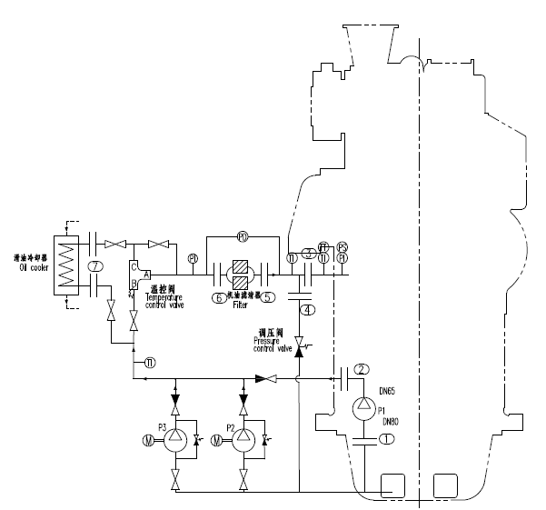

3.1.3 Compressed air system
The generator is started by the compressed air. Compressed air from the air receivers will, after reduced pressure and filtered through pressure reducing valve set fitted on engine, drive air motor to engage flywheel gear ring and start generator.

The system includes:
— CZ20/30 air compressor 1 sets
— 500L 3.0MPa air bottle
— pressure reducing valve
— air purifying filter
— start solenoid set
— manual starting valve
Power plant black start can be realized by adding one diesel engine driven air compressor (option).
压缩空气系统
由压缩空气启动发电机。压缩空气通过空气接收装置，在降低压力后，通过安装在发动机上的压降阀进行过滤，使空气马达与飞轮齿轮环接触，启动发电机。
该系统包括:
-20-30空气压缩机1套
-500L 3.0 MPa空气瓶
——减压阀
——空气净化过滤器
——启动电磁阀组
——手动起动阀
通过添加一个柴油机驱动的空气压缩机(选项)，可以实现电厂的黑启动。

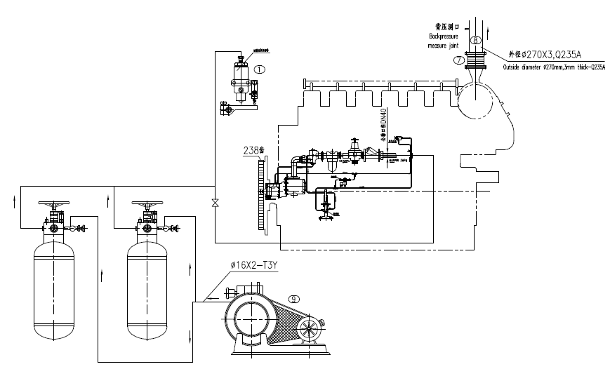

3.1.4. Cooling water system
The generator adopts two loops cooling type, that is low temperature water circuit and high temperature water circuit. Both of the two systems’ heat will emit through radiator.

The generator’s cooling water will be circulated by water pump built on diesel engine, both of the two systems are fitted with high positioned expansion water tank for cooling water making up and deaeration.
冷却水系统
该发电机采用了两种循环冷却式，即低温水回路和高温水回路。两个系统的热量都会通过散热器散发。
该发电机的冷却水将由柴油发动机上的水泵循环使用，这两种系统都装有高定位膨胀水箱，用于冷却水。
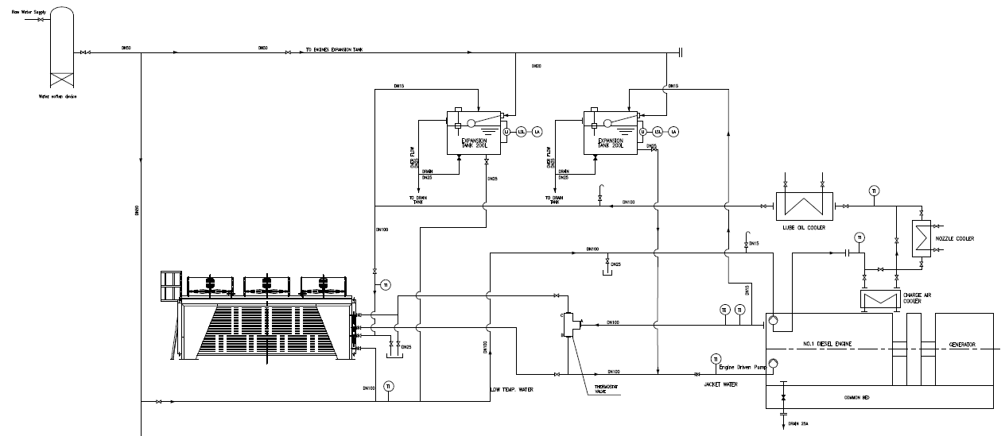
Cooling water system include：
200m3 countercurrent closed cooling tower for cooling water (circulating water flows from top to bottom and air flows from bottom to top)
Size 5 * 2.2 * 2.75 m.
-The metal outer plate is durable and has strong anticorrosion ability.
- large cooling area,
- suitable for high and low temperature cooling
冷却水采用200m3逆流闭式冷却塔（循环水自上而下流动，空气自下而上逆向流动）
尺寸5*2.2*2.75m.
-金属外板坚固耐用,防腐能力强..
-冷却面积大,
-适用于高,低温冷却

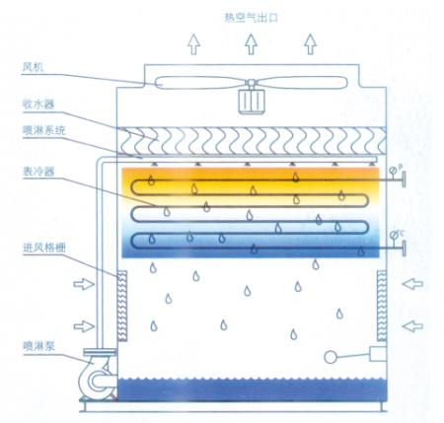

3.1.5. Intake and exhaust system
Packaged generator air intake adopts container forced ventilation mode, fans at engine turbocharger end will draw fresh air outside into container, part of the air will enter diesel engine combustion after charged by turbocharger and afterwards emit to the atmosphere through exhaust turbine and silencer, the rest of the air will be drawn out by axial fan by means of convection.

Intake and exhaust system includes：
—container axial fan
—exhaust expansion joint
— exhaust silencer
-exhaust boiler
进排气系统
发电机进气采用容器强制通风模式,在发动机涡轮增压器将新鲜空气进入容器,空气的一部分将进入柴油机燃烧后收取的涡轮增压器,然后排放到大气中通过排气涡轮和消音器,其余轴流式通风机的空气将通过对流。
进气和排气系统包括:
容器轴流式通风机
排气伸缩接头
—排气消声器
__废气锅炉
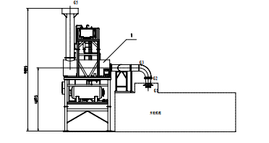

3.1.6. 电气系统
Electric system
本发电站，共7台发电机组,按并网发电和电气控制子系统和一个电站总控室进行方案设计。
This power station, a total of 7sets generator sets, according to the grid generation and electrical control subsystem and a power station control room for the scheme design.
发电单元电气主要由高压供电系统、主发电机、发电机组控制系统、操作站、单元公共控制系统，安全监控系统。发电单元电气系统结构框图见附图资料。
The electric system of generating units mainly consists of high-voltage grid connection and power supply system, main generator, generator set control system, generating unit operating station, public unit control system and safety supervision system. The structured diagram for the electric system of generating units is shown in the attached diagram.
高压并网及供电系统
High-voltage grid connection and power supply system
发电单元高压并网及供电系统主要由7台机组并网柜、1台出线柜、1台PT柜、1台联络柜、1台站用开关柜,共11面高压开关柜、控制元件及电力电缆组成。安装在电站发电单元高压控制室。主要负责发电机组并网合闸电力功给和主发电机保护及线路保护，以及给发电单元用电设备供电。
The high-voltage grid connection and power supply system for generating units are mainly composed of 7 grid-connected unit cabinets, 2 outgoing cabinets, 1 PT cabinets, 1 contact cabinets and 1 station switch cabinet. total of 11 high-voltage switch cabinets, control elements as well as power cables. It is installed at the high-voltage generating unit control room of the power station. It is mainly used to supply grid-connected closing power to generator sets, protect the main generator and lines, and supply power to electrical equipment in generating units.
高压开关柜安装在高压控制室，采用按国标标准设计生产的KYN28A-12(Z)中置式高压开关柜，真空断路器，微机保护，电流互感器，电压互感器及其它电气元件均采用国内知名品牌(用户也可选装)。高压开关柜主要有柜体和手车两大部分。柜体分断路器室、母线室、电缆室和低压室，各功能单元室相互独立，并有可靠接地装置。高压室上方有压力释放装置，进出线采用地沟进出方式，机房为高压柜正面和背面留有足够空间，安装、调试和维护可方便地从正面和背面进行。
The high-voltage switch cabinet is installed in the high-voltage control room, and is of KYN28A-12(Z) central-positioned type designed and produced based on the international standard, in which the vacuum circuit breaker, microcomputer protection, current transformer, voltage transformer and other electric elements are of famous domestic brands (they can also be selectively installed according to the user’s instructions). The high-voltage switch cabinet mainly consists of two parts, body and handcart. In the cabinet body, the sub-circuit breaker chamber, busbar chamber, cable chamber, low voltage chamber and various functional module chambers are independent from each other and are equipped with reliable earthing devices. There is a pressure release device above the high voltage chamber, incoming and outgoing lines are set in trenches, and sufficient spaces are reserved in the machine room for the front and back of high voltage cabinet, so that installation, debugging and maintenance can be conveniently carried from the front and back.
主要保护有：
Main protections are:
1). 发电机组差动保护
Differential protection for generator set
2). 定子接地保护
Stator ground protection
3). 机组逆功保护
Reverse power protection for the unit
4). 机组过电流、过电压保护
Overcurrent and overvoltage protection for the unit
5). 超频、低频保护
Overfrequency and under frequency protections
6). 三相电压过低或过高。
Too high or low three-phase voltage
7). 电流、电压不均衡。
Current and voltage imbalance
8). 励磁回路接地/失磁。
Excitation circuit grounded/excitation loss
9). 定子线圈接地
Stator coil grounded

主发电机Main generator
发电机组主发电机发电机为同步、直驱、6抽头、紧密耦合型、低数量旋转零件、永磁式、无刷旋转磁场发电机。Generators are synchronous, direct-driven, 6-tap, tightly coupled, low-number rotating parts, permanent magnet, brushless rotating magnetic field generators.
发电机与发动机是紧密耦合，主转子通过半弹性驱动磁盘固定在发动机飞轮上，保证持久校直。发电机采用防滴式设计和防护，按照IEE、NEMAMG-1-22标准组装，双排轴承、凸极、旋转磁场。旋转磁场线圈为湿式、精密分层绕制，每层磁性导线涂有环氧材料。发电机由三相永磁型发电机组向励磁器提供励磁电源，增加了非线性负载的承受能力，保证了在短路状况发生时可以承受10秒的250%的额定电流。发电机上配备一个主端子扩展箱，安装发电机的导线、端子扩展母线，调压器和必须的CT和PT。发电机上装有一个220V的空间加热器，加热器上嵌有温度探测器，加热器可以保证发电机组的绕组在非运行状态下保持干燥。
The generator is tightly coupled with the engine, and the main rotor is fixed on the flywheel of the engine through a semi-flexible magnetic driver disk to guarantee enduring alignment. The generator is drip proof in design and protection, is assembled as per IEE and NEMAMG-1-22, and is equipped with double-row bearings, salient poles and rotary magnetic fields. The rotary magnetic field is of wet type and wound in layers precisely, and each layer of magnetic conductor is smeared with epoxy materials. In the generator, the three-phase permanent magnetic generator set is set to provide excitation sources to the exciter, enhancing the bearing capacity of nonlinear load and guaranteeing that 250% of the rated current can be born for 10 seconds in case of a short circuit. A main terminal extension box is provided on the generator, in which the generator conductor, terminal extension busbar, voltage regulator and necessary CT and PT are mounted. A 220V space heater is mounted on the generator, on which a temperature detector is embedded. The heater can guarantee that the windings of generator set can be dry all the time, in the non-operating state.
调压器为数子式调压器，具有自动电压调节，功率因数调节，无功功率调节三种调节模式，可根据需要进行设置。
The voltage regulator is a digital voltage regulator having three regulating modes of automatic voltage regulation, power factor regulation and reactive power regulation. It can be set as required.
电压调节器具有发电机过电压、发电机低电压、失励磁、瞬间磁场过电流、过励磁、传感失效、三极管故障监测、内部监测器故障、内部存储器故障等功能。
The voltage regulator has functions including generator overvoltage, generator low voltage, excitation loss, instant magnetic field overcurrent, overexcitation, sensing failure, triode failure monitoring, internal monitor failure, internal memory failure, etc.
发电机组控制系统主要由发电机组控制面板，发动机旁控制面板，机组辅助控制面板组成。机组控制系统示意图如下:
generator set control system mainly consists of the generator set control panel, control panel aside the engine and auxiliary control panel for the unit. The diagram of the unit control system is as follows:
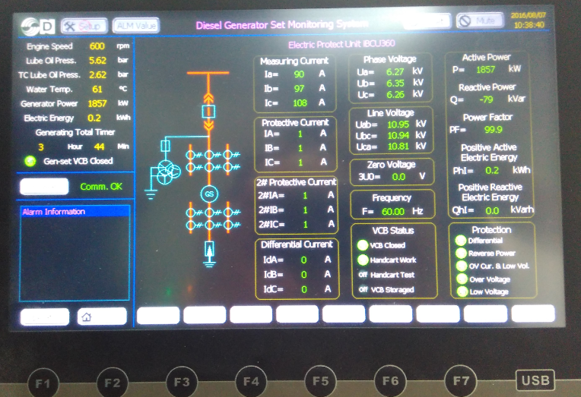

发电机组控制面板
Generator set control panel
发电机组控制面板主要由可编程控制器(PLC)，人机界面、数字式自动并机并网模块、负载分配模块、控制按钮、指示灯、控制电源、小型断路器、继电器组成。功能描述如下：
The generator set control panel mainly consists of the programmable controller (PLC), human-computer interface, digital automatic unit and grid connection module, load distribution module, control button, indicator light, control power supply, small circuit breaker and relay unit. The functions are described as follows:
1) 控制功能：自动/手动起动，延时停机，手动停机，转速控制，同步并机并网控制,有功功率控制，无功功率控制，可编程逻辑控制等。
Control function: automatic/manual start, delay shutdown, manual shutdown, speed control, synchronous unit and grid connection control, active power control, reactive power control, programmable logic control, etc.
2) 数字显示功能：发动机转速、排温，发动机工作小时，机油压力，冷却水温，直流电压，机组电压，电流，频率，实际输出功率，无功功率，视在功率，电度计量，功率百分数，功率因数，故障代码显示。
Digital display function: display engine speed and discharging temperature, engine working hours, engine oil pressure, cold water temperature, direct voltage, unit voltage, current, frequency, actual output power, reactive power, apparent power, measurement of electricity degree, power percent, power factor and fault code.
3) 故障保护停机功能：机油低压力停机保护，高水温停机保护，超速保护，超速起动保护，紧急停机保护，低电压或高电压保护，低频率或高频率保护，过电流保护，逆功率保护。各种预报警和报警信号指示。
Fault containment shutdown function: engine oil low pressure shutdown protection, high water temperature shutdown protection, over-speed protection, over-speed start protection, emergency shutdown protection, low or high voltage protection, low or high frequency protection, over-current protection, reverse power protection. Various pre-alarm and alarm signal indications.
发动机旁控制面板
Control panel aside the engine
发动机机旁控制面板主要负责发动机启动、停机控制、发动机转速控制,发动参数监控、报警、数据上传等功能。
The control panel aside is the engine mainly used for engine start and shutdown control, engine speed control, monitoring, alarm and upload of engine parameters, etc.
机组辅助控制面板
Auxiliary control panel for the unit
辅助控制系统主要负责发动机滑油系统、冷却水系统，空气压缩系统等辅助设备的电源和控制。
The auxiliary control system mainly is used for power supply and control of auxiliary equipment including engine lubricating oil system, cooling water system, etc.
机组控制系统特点
Characteristics of unit control system
1) 发动机燃烧控制、机组功率控制、机组并网控制都使用woodword最新的控制器，机组核心控制器采用 Netmation控制器，具有极高可靠性，技术先进，功能强大。可对发电机组进行各种工作状态的监测，控制和保护可以保证机组长时间稳定高效的运行。控制器操作简单，可以在面板上进行参数设置，控制机组的启动、运转和停车，也可通过计算机在远端监控中心对控制器进行设置，监测机组各种参数，控制机组的启动、运转和停机。
The latest woodword controller shall be adopted in engine combustion control, unit power control and unit grid connection control, and the Netmation controller manufactured shall be used as the unit core controller, with extreme high reliability, advanced technology and powerful features. Various kinds of operating conditions of a generator set can be monitored and control and protection can ensure stable and efficient operation of the generator set for a long time. The controller is easy to operate and its parameters can be set via the panel to control startup, operation and shutdown of the controller unit, and the controller also can be set through the remote monitoring center of computer to monitor the unit parameters of different kinds and control startup, operation and shutdown of the unit.
2) 机组机旁柜和并网柜都配置了液晶屏，可让用户随时了解机组的运行状况。在系统设计上，保证用户不做任何操作就可以清晰完整看到机组所有运行状态和运行参数。
Both of the cabinet next to the unit and the grid-connection cabinet shall be equipped with LCDs, so that the users can understand the operating condition at all times. The system design can ensure that the users, without any operation, can see all operating conditions and parameters clearly and completely.
3) 系统硬件构架充分考虑了可扩展性，使用户可以自由地把机组进行分组管理，包括异地机组都可以进行统一管理。
The system hardware architecture has taken into full account extendibility so that the users can group the units into different parts for management at their disposal and the units located in different places also can be managed in a unified mode.
4) 辅助设备控制配置PLC模块，根据机组工作的需求逻辑，对发电机组的冷却水、润滑油的手动/自动预热，润滑油，燃气的手动/自动预供等进行控制，保证机组可以随时和长期的正常运行。
PLC module shall be provided for the auxiliary machinery control, and according to the logic of operating demands of units, manual/automatic preheating of cooling water and lubricating oil and manual/automatic supplying of lubricating and gas for a generator set shall be controlled to ensure the unit can normally and long operate at any time.
5) 机组并网和并网安全保护由控制系统全自动实现。当发动机满足条件，系统会自动启动并网程序，完成自动并网功能。当触发脱网条件，程序控制自动脱网。
The unit grid connection and grid-connection safety protection can be realized automatically through the control system. When the engine meets the required conditions, the system will automatically start the grid connection procedure and then complete the automatic grid connection function. If the grid-disconnected condition is triggered, the procedure control will be disconnected from the grid.
6) 多机组可以实现功率自动分配和功率自动转移。功率分配和功率转移的策略可以根据用户预设方案执行。
The multi-unit can realize the automatic power distribution and the automatic power transfer. The strategies of power distribution and transfer can be carried out based on the user presetting scheme.
7) 发动机自动控制。发动机所有运行过程和参数都在控制系统监控之中，当任何一个参数触发报警，系统都会启动预设的报警处理。
The engine can be controlled automatically. All operating processes and parameters of the engine can be monitored and controlled by the control system, and when any one of these parameters triggers an alarm, the system will start the preset alarm processing.
8) 供气系统的安全防护的自动控制。
The safety protection of gas supply system can be controlled automatically.
9) 发动机参数，机组参数的采集传输：排温、油水温度压力、转速、各控制点状态、所有的电参数都可以实现遥测功能。
Acquisition and transmission of engine parameters and unit parameters: discharge temperature, temperature and pressure of oil and water, rotational speed, status of each control point and all electrical parameters can realize the function of telemetering.
10) 系统采用以太网方式组成通信网络， 这样就让系统具备了灵活的可扩展性和可远程访问的功能，可以通过网络连接，就可以授权查询机组状态，对机组进行控制。具体组网的方式不受限制，可以是有线网络、无线网络、以及internet网络。
The system adopts the Ethernet mode to form a communication network, so that the system can be provided with the functions of flexible extendibility and remote access and connected via the network, and the system can be authorized to query the unit status and control the unit. The specific networking methods are not limited, including wired network, wireless network and internet network.

3.1.7 系统安全保护措施
System safety protection measure
1) 系统对机组提供了完善的安全保护措施，当出现用户预定的状况，系统会按照预定程序实施系统保护，降功率、脱网、停机组等程序，保证人员和设备的安全。
The system has been designed with complete safety protection measure for unit . When designed situation happens, the system will activate protection according to preset procedures, reducing the power, disconnecting the network, shutting down the unit, so as to guarantee personnel and equipment safety.
对于机组并网系统，除了控制系统提供保护之外，机组电气控制系统整套完善的自动保护功能配置。
As for unit networking system, apart from being protected via control system, unit electrical system also has a complete set of automatic protection function,
包括：
Including
输出电压过高/过底告警保护停机
Alarming and shutting down by over-voltage/under-voltage
频率过高/过低告警保护停机
Alarming and shutting down by over-frequency/under-frequency
逆功率保护
Reverse-power protection
差动保护
Differential protection
接地故障保护
Grounding fault protection
输出过载或短路告警保护停机
Alarming and shutting down by over-load or short circuit
水温过高告警保护停机
Alarming and shutting down by water over-temperature
发电机绕组温度过高告警
Alarming by generator winding over-temperature
发电机轴承温度过高告警
Alarming by generator bearing over-temperature
对于控制系统，软件本身也提供了防护措施，机组控制系统和机组数据，都提供了多重安全防护功能。
For the control system, software protection measure is adopted to protect the safety of generator unit control system and data.

附件 1 标准随机备件清单 list of standard spare parts,

标准随机工具 list of standard tools
备件清单spear part list：
序号  No. | 名称  Description | 数量/套  Qty. | 图册  Plate | 件号  Item
 | Cylinder Head气缸盖:
1 | Valve spindle, inlet 进气阀 | 1 | 50502 | 262
2 | Valve spindle, exhaust排气阀 | 1 | 50502 | 561
3 | Conical ring in 2/2锁夹 | 2 | 50502 | 178
4 | Inner spring内弹簧 | 2 | 50502 | 333
5 | Outer spring外弹簧 | 2 | 50502 | 201
6 | Valve seat ring, inlet进气阀座 | 1 | 50501 | 184
7 | Valve seat ring, exhaust排气阀座 | 1 | 50501 | 184
8 | Safety valve安全阀 | 1 | 50508 | 108
9 | Gasket, coaming垫片 | 1 | 50510 | 171
10 | Gasket, top cover垫片 | 1 | 50510 | 014
11 | O-ring, cylinder head O形圈 | 2 | 50501 | 196
12 | Valve rotators转帽 | 2 | 50502 | 191
Piston and Connecting Rod, Cylinder Liner
活塞、连杆和气缸套：
13 | Sealing ring密封圈 | 1 | 50610 | 031
14 | Sealing ring密封圈 | 1 | 50610 | 055
15 | Connecting rod bearing连杆瓦 | 1 | 50601 | 139
16 | Connecting rod stud连杆螺栓 | 2 | 50601 | 152
17 | Connecting rod nut连杆螺母 | 2 | 50601 | 164
18 | Bush for connecting rod连杆衬套 | 1 | 50601 | 056
19 | Piston pin活塞销 | 1 | 50601 | 019
20 | Retaining ring挡圈 | 2 | 50601 | 032
21 | Piston ring活塞环 | 1 | 50601 | 093
22 | Piston ring活塞环 | 1 | 50601 | 103
23 | Piston ring活塞环 | 1 | 50601 | 235
24 | Oil scraper ring油环 | 1 | 50601 | 127
25 | O-ring, cylinder liner O形圈 | 2 | 50610 | 043
26 | O-ring, inlet bend O形圈 | 2 | 50610 | 102
27 | O-ring, inlet duct O形圈 | 1 | 50610 | 126
28 | O-ring, cooling water connections O形圈 | 12 | 50610 | 138
Operating Gear for Valve and Fuel Injection Pumps
气阀传动机构和燃油喷油泵：
29 | Sealing ring 密封圈 | 4 | 50801 | 185
 | Engine Frame and Base Frame机架和公共底座：
30 | Main bearing shells主轴瓦 | 1 | 51101 | 157
31 | Thrust washer止推片 | 2 | 51101 | 253
32 | Stud主轴承螺栓 | 2 | 51101 | 169
33 | Nut 主轴承螺母 | 2 | 51101 | 170
34 | O-ring O形圈 | 2 | 51106 | 058
 | Turbocharger System涡轮增压系统：
35 | Gasket垫片 | 1 | 51202 | 335
36 | Gasket垫片 | 1 | 51202 | 492
37 | O-ring, cooling water connections O形圈 | 1 | 51202 | 311
38 | O-ring, cooling water connections O形圈 | 1 | 51202 | 264
39 | Disc 垫片 | 2 | 51202 | 323
40 | Standard spare parts for TC增压器标准备件 | 1

工具清单Tools list：
序号 | 名称 | 数量/套 | 图册 | 件号
 | Cylinder Head气缸盖：
1 | Lifting tool for cylinder head 气缸盖起吊工具 | 1 | 52005 | 01
2 | Mounting tool for valves气阀安装工具 | 1 | 52005 | 05
3 | Max. pressure indicator 爆压表 | 1 | 52005 | 10
4 | Grinding ring for cyl. head and cyl. Liner  气缸盖和气缸套研磨工具 | 1 | 52005 | 20
5 | Tool for grinding of valves气阀研磨工具 | 1 | 52005 | 55
6 | Handwheel for indicator valve示功阀手轮 | 1 | 52005 | 65
Piston, Connecting Rod and Cylinder Liner
活塞、连杆和气缸套：
7 | Lifting tool for piston活塞起吊工具 | 1 | 52006 | 05
8 | Eye bolt for piston lift at check of connecting rod  活塞起吊长螺栓 | 1 | 52006 | 07
9 | Back stop for cylinder liner气缸套压管 | 2 | 52006 | 09
10 | Guide ring for mounting of piston活塞导向圈 | 1 | 52006 | 11
11 | Piston ring opener活塞环扩张钳 | 1 | 52006 | 13
12 | Testing mandrel for piston- and scraper ring grooves  活塞环槽塞规 | 1 | 52006 | 14-15-16
13 | Plier for piston pin lock ring活塞销卡簧钳 | 1 | 52006 | 20
14 | Guide fork for connecting rod 连杆安装工具 | 1 | 52006 | 24
15 | Torque spanner 20 - 120 Nm扭力扳手 | 1 | 52006 | 26
16 | Torque spanner 50 - 300 Nm扭力扳手 | 1 | 52006 | 27
17 | Lifting tool for cyl. liner 气缸套起吊工具 | 1 | 52006 | 45
18 | Honing brush珩磨刷 | 1 | 52006 | 50
19 | Funnel for honing of cylinder liner气缸套珩磨导管 | 1 | 52006 | 51
20 | Magnifier (30x) 放大镜 | 1 | 52006 | 55
 | Operating Gear for Inlet Valves, Exhaust Valves and Fuel Injection Pumps气阀传动机构和燃油喷油泵：
21 | Feeler gauge for inlet valves进气阀塞尺 | 2 sets | 52008 | 01
22 | Feeler gauge for exhaust valves排气阀塞尺 | 2 sets | 52008 | 02
23 | Extractor for thrust piece，on roller guide for fuel pump  喷油泵顶块调整扳手 | 1 | 52008 | 06
 | Crankshaft and Main Bearings曲轴和主轴承：
24 | Torque spanner (Vibration damper)力矩扳手 | 1 | 52010 | 01
25 | Crankshaft alignment gauge, autolog曲轴甩档表 | 1 | 52010 | 05
26 | Guide pipe for main and guide bearing caps 主轴承导向管 | 2 | 52010 | 10
27 | Lifting straps for main and guide bearing caps主轴承盖起吊工具 | 2 | 52010 | 15
28 | Dismantling tool for guide bearing shells 上止推瓦拆卸工具 | 1 | 52010 | 19
29 | Tool for upper main bearing上轴承瓦拆卸工具（含O形圈） | 1 | 52010 | 22
30 | O-ring O型圈 | 1 | 52010 | 23
31 | Guide tools for mounting of upper guide bearing shell  上止推瓦导向工具 | 1 | 52010 | 25
32 | Angle for mounting on crankweb without counterweight(for checking of main bearings alignment - autolog)支架 | 4 | 52010 | 40
 | Turbocharger System涡轮增压系统：
33 | Container complete for water washing of compressor side  压气机水洗工具 | 1 | 51205 | 318
34 | Blowgun for dry cleaning of turbocharger涡轮干洗喷枪 | 1 | 51210 | 136
35 | Wet cleaning tool for turbocharger涡轮水洗工具 | 1
Fuel Oil System and Injection Equipment
燃油系统和喷油装置：
36 | Pressure testing pump, complete喷油器试验台 | 1 | 52014 | 01
37 | Cleaning tool for fuel injector喷油器清理工具 | 1set | 52014 | 10
38 | Spanner for high pressure pipe高压油管旋入压圈扳手 | 1 | 52014 | 15
39 | Spanner for fuel injection pump, left喷油泵左扳手 | 1 | 52014 | 20
40 | Spanner for fuel injection pump, right喷油泵右扳手 | 1 | 52014 | 25
41 | Spanner for fuel injection pump, right喷油泵右扳手 | 1 | 52014 | 27
42 | Grinding tool for fuel injector seat喷油器座研磨工具 | 1 | 52014 | 35
43 | Extractor for fuel injector喷油器拉拔工具 | 1 | 52014 | 40
44 | Measuring device for plunger lift 柱塞升程测量工具 | 1 | 52014 | 42
 | Hydraulic Tools液压工具：
45 | Pressure pump, complete高压注油泵（手动泵） | 1 | 52021 | 01
46 | Air driven high pressure pump for hydraulic valve  风动液压泵 | 1 | 52002 | 460
47 | Distributing piece for cylinder head 气缸盖分配块（七通接头） | 1 | 52021 | 15
48 | Distributing piece for main and guide bearings  主轴承分配块（三通接头） | 1 | 52021 | 20
49 | Hydraulic tools for cylinder head, complete气缸盖液压拉伸器 | 1 | 52021 | 25
50 | Tools for cylinder head 缸套工具 | 1 | 52021 | 36
51 | Hydraulic tools for main and guide bearings, complete  主轴承液压拉伸器 | 1 | 52021 | 40
52 | Hose for hydraulic tools高压软管 | 6 | 52021 | 49
53 | Hose with unions for connection of oil pump and distributor piece  高压软管 | 1 | 52021 | 51
54 | Spacer ring (only to be used if the vibration damper is too  big for the hydraulic tools)垫片 | 2 | 52021 | 65
55 | Hydraulic tools for connecting rod连杆液压拉伸器 | 1 | 52021 | 70
56 | Angle piece角接头 | 1 | 52021 | 76
 | 其他工具
57 | 整机起吊工具 | 1套
58 | Standard tools for TC 增压器标准工具 | 1套

